CE5525 -Atmospheric Physics and Chemistry

**Design of Real Time weather monitoring instrument using Internet of thing Module**

November 10, 2023

Prof. Dr. Chandan Sarangi

Department of civil engineering

IIT Madras

**Introduction:**

In the contemporary era of meteorology, the integration of Internet of Things (IoT) modules has significantly transformed the precision and efficiency of real-time weather monitoring. This technological convergence has enabled the seamless collection of crucial weather data through a network of advanced sensors, presenting a paradigm shift in how meteorological information is gathered and analyzed.

The core sensors utilized in this advanced weather monitoring system are instrumental in providing accurate and real-time data. The wind speed is measured using a three-cup anemometer, complemented by proximity sensors to calculate wind speed precisely. Rainfall is gauged through a rain gauge equipped with ultrasonic sensors, which trigger a DC pump once the gauge reaches its maximum capacity, ensuring continuous functionality. Additionally, wind direction is accurately measured via a vane, employing a meticulously designed 7-bit grey encoded disc, in combination with LED and LDR or absolute encoders. This system ensures exact calculations for wind direction, crucial for precise meteorological observations.

The transmission of this vital weather data is facilitated through IoT-based NodeMCU devices, establishing a robust connection between the sensors and the visualization platforms. MATLAB and ThingSpeak are utilized as visualization tools, allowing for the comprehensive analysis and interpretation of the collected data. This combination of sensors and IoT technology not only ensures real-time data collection but also empowers meteorologists and weather enthusiasts with insightful and actionable information for various applications.

By amalgamating sophisticated sensors, IoT modules, and advanced visualization software, real-time weather monitoring has reached an unprecedented level of accuracy and reliability. This integration not only enhances our understanding of weather patterns but also holds the potential to revolutionize various industries reliant on weather information, from agriculture to transportation and disaster management.

**Literature Survey:**

**Anemometer**

The evolution of anemometry, the measurement of wind speed, has seen significant advancements since the invention of the four-cup anemometer by Robinson of Ireland in 1846. This design laid the groundwork for subsequent anemometer developments. Pindado (2012) conducted an extensive study, evaluating 21 different cup and arm models. He validated the model proposed by Kondo et al. in 1972, affirming its accuracy and reliability in wind speed determination.

Lindley (1975) and Pindado (2012) independently conducted observations that led to a consensus suggesting the ideal K factor for anemometers to be 0.4. This K factor, an essential parameter in converting anemometer rotations to wind speed, signifies a crucial aspect in the accuracy of wind measurement instruments.

$$K=\frac{Wind speed (m/s)}{RPM of Anemometer}=\frac{Cup Radius\left(r\right)+armlength}{CupRadius}$$

Robinson's pioneering four-cup anemometer marked the inception of modern wind-speed measurement devices. Subsequent studies, including Pindado's extensive analysis of various models and the validation of Kondo et al.'s analytical model, have played a pivotal role in refining and standardizing wind speed measurement techniques.

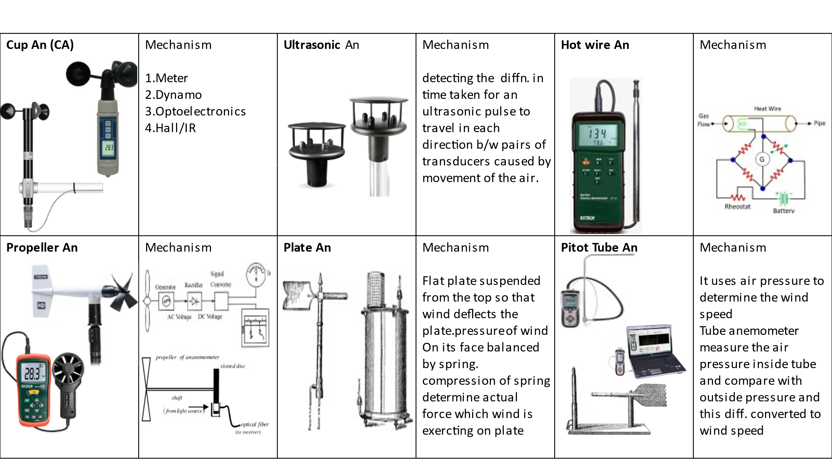Market analysis of Cup anemometer (An)

Rain guage (Rg)

Rain gauges play a pivotal role in meteorology, aiding in the precise measurement and recording of precipitation. This literature survey provides an insightful examination of various rain gauge types: Non-Recording Type, Recording Type, Weighing Bucket Type, Tipping Bucket Type, and Floating or Natural Siphon Type Rain Gauges.

Non-Recording Type Rain Gauges, the earliest and simplest in design, accumulate rainfall without automatic measurement or data recording. Their straightforward design and low maintenance make them accessible and reliable for many applications, especially in areas with limited resources or challenging conditions.

Recording Type Rain Gauges, in contrast, offer a more advanced approach by automatically measuring and recording rainfall data. These gauges, equipped with sophisticated mechanisms, enable continuous data collection, providing valuable real-time information for meteorological analysis. The evolution of technology has led to the development of diverse models and recording methods, enhancing accuracy and efficiency.

Weighing Bucket Type Rain Gauges employ a system of weighing mechanisms to measure precipitation. These gauges offer precise measurements through the collection of rainfall in a bucket that, upon reaching a specific weight, triggers data recording. Their accuracy and reliability in measuring both light and heavy rainfall make them a popular choice for many meteorological purposes.

Tipping Bucket Type Rain Gauges operate through a mechanism where rainwater fills a small bucket, causing it to tip and empty. This action initiates data recording, enabling precise measurements with minimal maintenance requirements. Their adaptability to various climates and suitability for remote data collection make them widely used in meteorological studies.

Floating or Natural Siphon Type Rain Gauges utilize the natural principle of a siphon to record rainfall. These gauges automatically measure and siphon collected water, ensuring accurate and consistent measurements. Their effectiveness in specific environmental conditions, where other gauge types might face limitations, marks their significance in meteorological research.

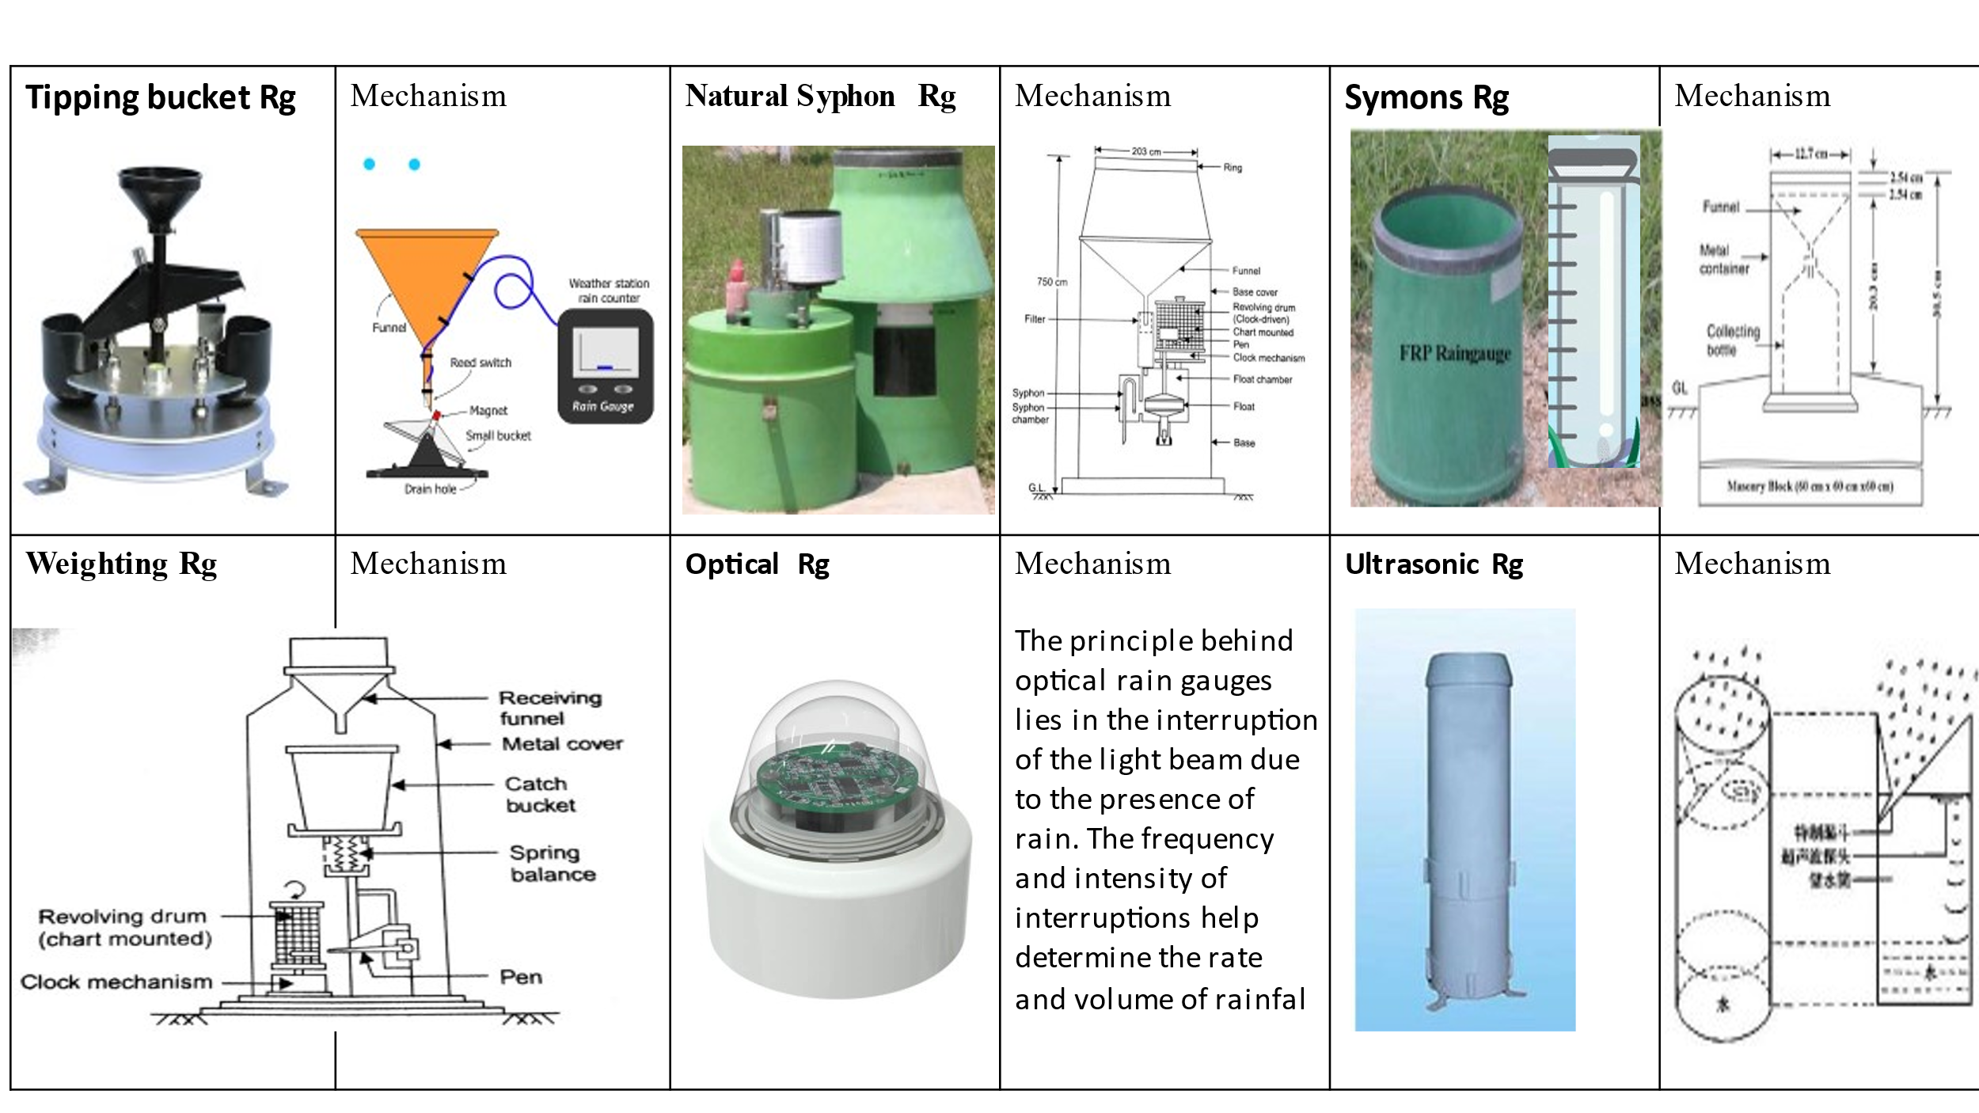Market survey

**Objective of the study:**

* Design & Development of Wind anemometer, Rain gauge and vane
* Integration of sensor with IOT Board
* Internet of thing
* Real time Weather monitoring

**Methodology:**

The methodology you've outlined appears to detail the steps involved in a comprehensive process of developing and integrating sensors within an Internet of Things (IoT) framework. Here's a brief breakdown of each step:

1. **Literature Survey & Market Study:**

This phase involves researching and reviewing existing literature, academic papers, and market studies to understand the current state of the art in sensor technology, IoT, and related fields. It helps in gathering knowledge, understanding trends, and identifying gaps or opportunities in the industry.

2. **Design Constraint Analysis:**

Identifying and analyzing the design constraints involves understanding the limitations or restrictions that might impact the design and implementation of the sensor system. This could include factors such as cost, size, power requirements, environmental conditions, etc.

3. **Computer-Aided Design & Simulation:**

Using software tools for computer-aided design (CAD) and simulation to create and visualize the design of the sensor system. This step allows for a virtual representation of the system, helping in understanding how it might function and identifying potential issues before physical implementation.

4. **Individual Hardware Interfacing & Testing:**

Implementing and testing the hardware components individually. This involves connecting the hardware components to ensure they function correctly. It's important to validate the performance and compatibility of each piece of hardware.

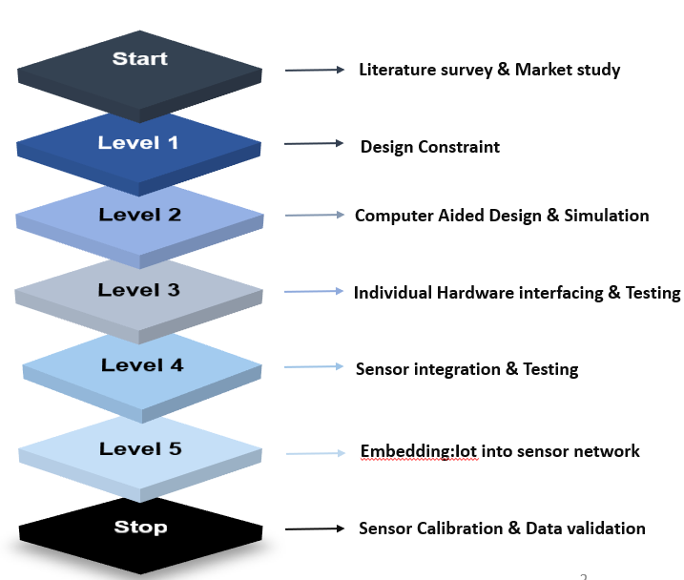5. **Sensor Integration & Testing:**

Integrating the sensors with other hardware components and systems and testing them to ensure they function together as intended. This phase involves checking communication protocols, data transfer, and overall system performance.

6. **Embedded IoT into Sensor Network:**

Integrating the sensors into an IoT framework. This involves setting up the infrastructure required for IoT communication, ensuring the sensors can communicate their data to a central network or server for processing and analysis.

7. **Sensor Calibration & Data Validation:**

Calibration ensures that the sensors are providing accurate measurements or data. This step involves adjusting or fine-tuning the sensors to ensure their accuracy and reliability. Data validation includes verifying and validating the data collected by the sensors to ensure it aligns with expected or known parameters.

This methodology provides a structured approach to developing and integrating sensor systems within an IoT framework, covering various crucial aspects from research to implementation, testing, and validation. Each step is essential in ensuring the system's functionality, accuracy, and reliability in real-world applications.

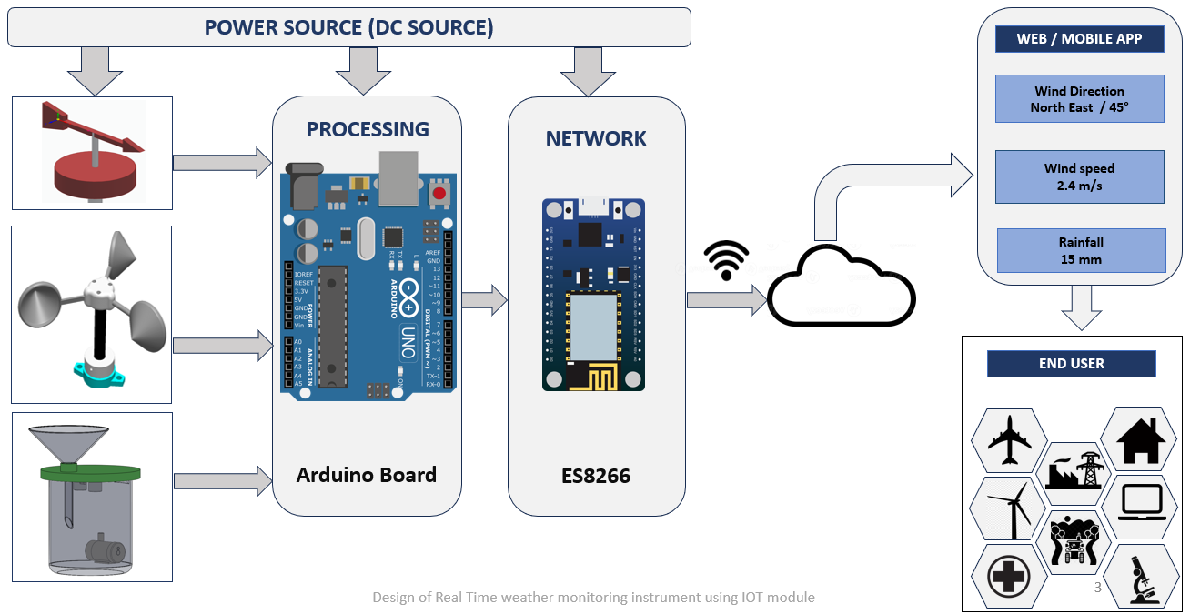

**Anemometer**

* four-cup anemometer developed by Robinson of Ireland in 1846.
* Pindado (2012) Test 21 different cup & arm model and find analytical model of Kondo et al.(1972) was proved to be accurate
* So, Observations from Lindley (1975) and pindado (2012) suggest that Cup Anemometer factor K factor to be 0.4(**Design constraint)**

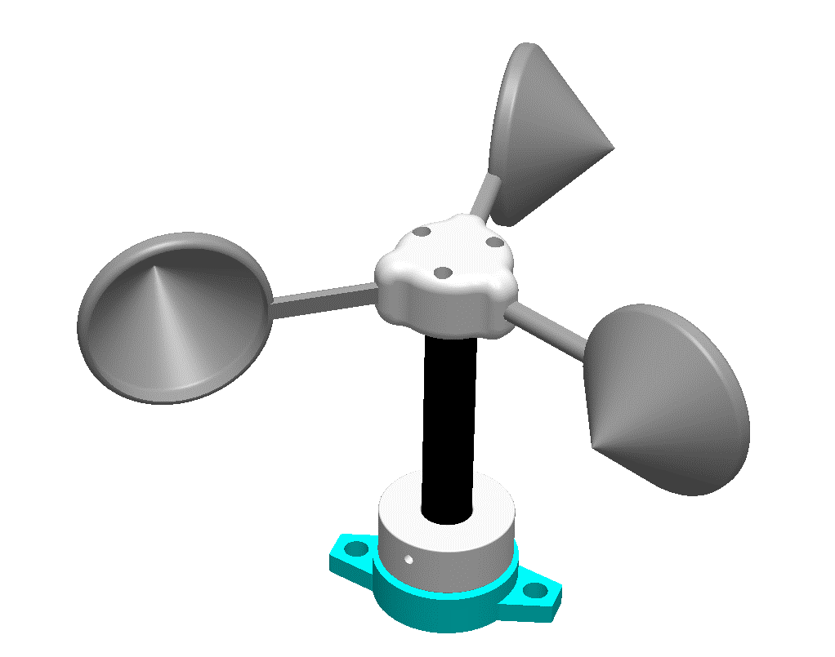

Cup arm

**Working principle:**



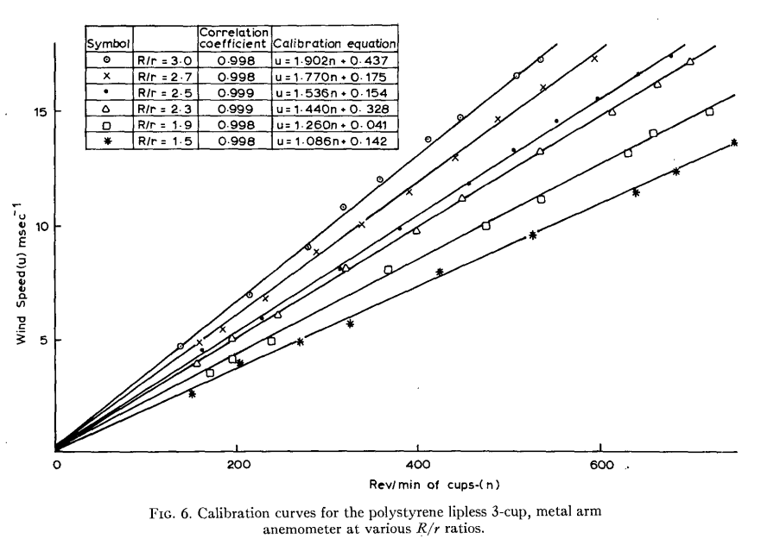

**Rain gauge**

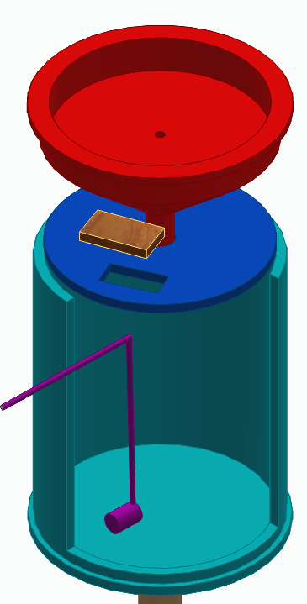

**Funnel**

**Ultrasonic sensor**

**Graduated**

**cylinder**

**Dc Pump**

**Working principle:**

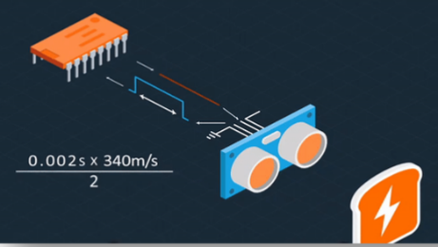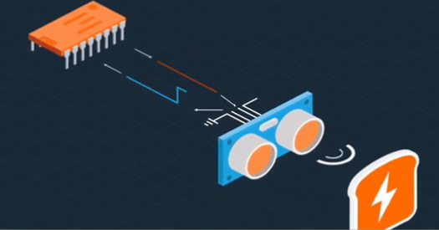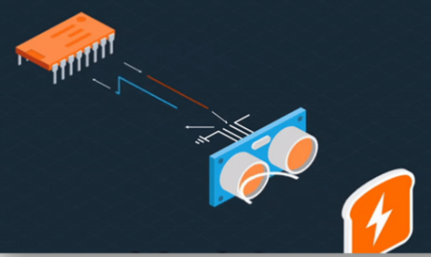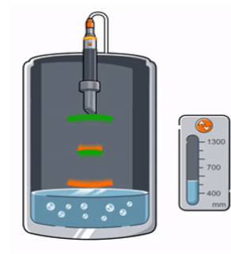

**Future work**

Wind vane:

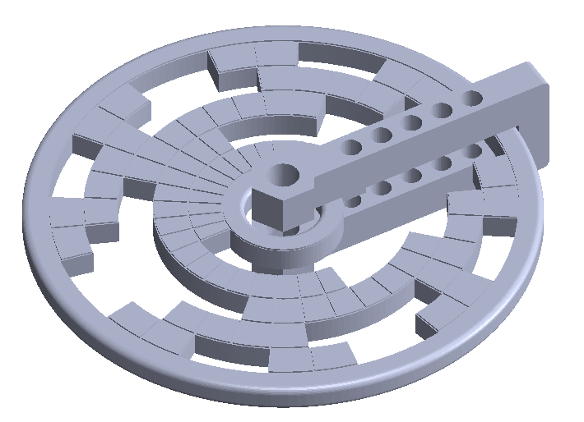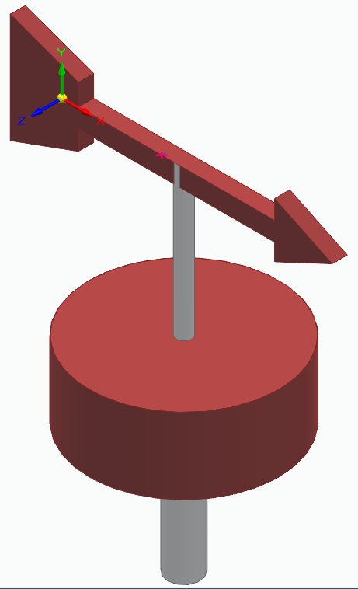

**Shaft**

**Vane**

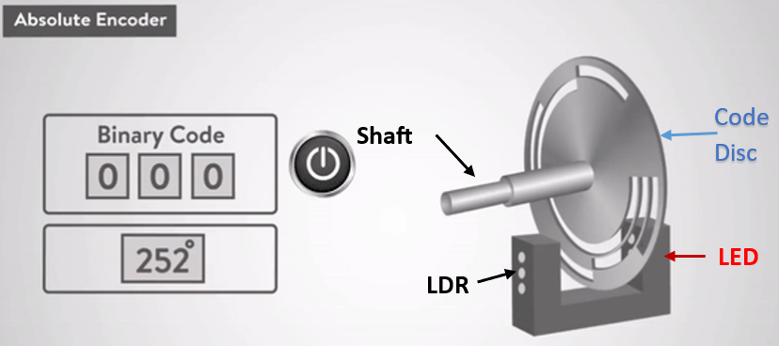**Working principle:**

Casing and assembly:

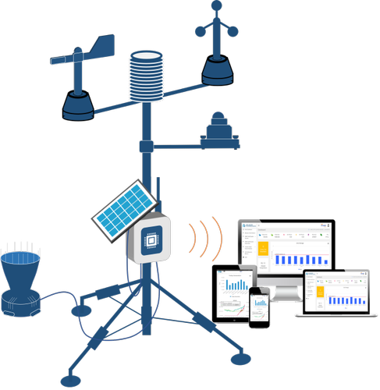

**Results and Discussion:**

Explain Results and Discussion from your project with neat figures and tables.

**Conclusions:**

Max 300 words.

**References:**

1. Avallone, E. *et al.* (2019) ‘An inexpensive anemometer using Arduino board’, *Facta universitatis - series: Electronics and Energetics*, 32(3), pp. 359–368. doi:10.2298/fuee1903359a.
2. Carlos-Mancilla, M.A. *et al.* (2020) ‘Educational mechatronics and internet of things: A case study on dynamic systems using meiot weather station’, *Sensors*, 21(1), p. 181. doi:10.3390/s21010181.
3. Coquilla, R.V., Obermeier, J. and White, B.R. (2007) ‘Calibration procedures and uncertainty in wind power anemometers’, *Wind Engineering*, 31(5), pp. 303–316. doi:10.1260/030952407783418720.
4. Lindley, D. (1975) ‘The design and performance of a 6-Cup anemometer’, *Journal of Applied Meteorology*, 14(6), pp. 1135–1145. doi:10.1175/1520-0450(1975)014&lt;1135:tdapoa&gt;2.0.co;2.
5. Pindado, S., Cubas, J. and Sorribes-Palmer, F. (2014) ‘The cup anemometer, a fundamental meteorological instrument for the wind energy industry. research at the IDR/UPM Institute’, *Sensors*, 14(11), pp. 21418–21452. doi:10.3390/s141121418.
6. Sharifabad, H.K., Mirzaei, O. and Talebi, M.H. (2011) ‘Design anemometer with transistor’, *Applied Mechanics and Materials*, 110–116, pp. 2628–2630. doi:10.4028/www.scientific.net/amm.110-116.2628.
7. Sheppard, P.A. (1940) ‘An improved design of cup anemometer’, *Journal of Scientific Instruments*, 17(9), pp. 218–221. doi:10.1088/0950-7671/17/9/301.

**Max 5 pages**

**APPENDIX 1**

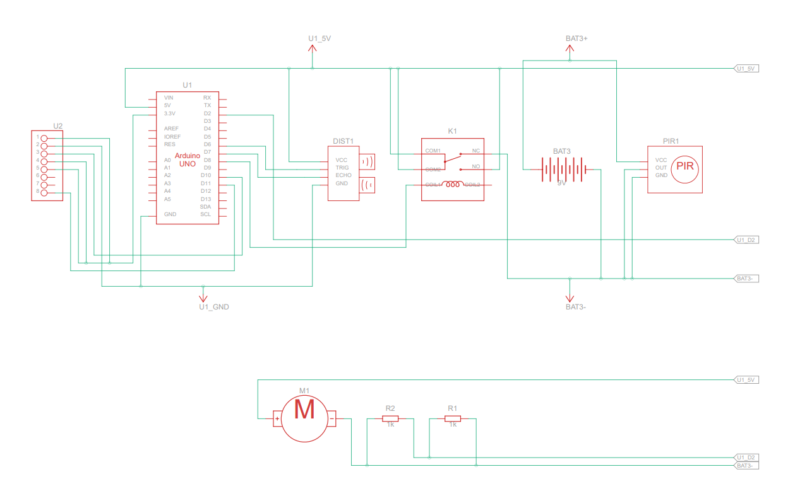

**APPENDIX 2**